Procedure for programming/accessing your pi via USB on a laptop or desktop. Distilled from Dan Aldred’s video by KM5L

Please mark this document up. If you find errors please mark in Red and let me know.
Disclaimer – if you are a ham for example and plan on doing a lot of field stuff with the pi then this is a good project. But, if you’re a “Home pi” guy, forget it, not worth the effort. The big advantage is not hauling extra mice, keyboard and monitors to the field.
These instructions were gleaned from the following video by Dan Aldred : https://www.raspberrypi.org/blog/#programming-pi-zero-usb
He did a good job on the video, but there were some not so intuitive spots, or at least to me, so if you’re hard headed like me then maybe this will help! There was at least two spots on the video where the vocal command did not equal the actual command – not sure what happened, maybe he went back to edit. – The below is what I used and it worked.
To be honest, it took longer than I thought . The good news is that much of it is “one off”.
Hint: Be sure to use the laptop you’re going to use in the field.
For amateur radio ops – I can see if you get pretty fast at this that it would likely be the default way you’d access the pi in the field. You probably would have a small laptop with you anyway, so the opportunity to not haul another keyboard, mouse and monitor is compelling, especially on SOTA or NPOTA trips.

Contents
Procedure for programming/accessing your pi via USB on a laptop or desktop. 1
Step 1 – Download 2
Step 2 – Extract the raspbian Jessie zip file 2
Step 3 – Use SD Formatter to burn the ISO image 2
The following steps are related to programming/operating the pi from your laptop USB 3
Step 4 – Connect the Pi Zero 3
Step 6 – Scroll to bottom, add a line 4
Step 7 – Edit cmdline.txt 4
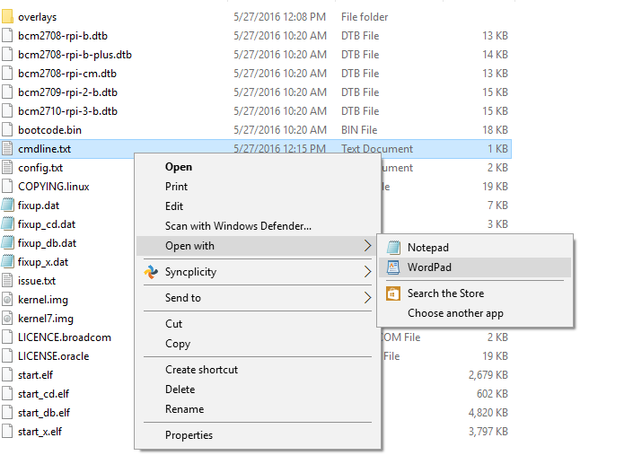 4
Step – Open Putty 5

The following steps are normal steps, for all Raspberry Pi typical installations
Step 1 – Download the latest Raspbian Jessie https://www.raspberrypi.org/downloads/raspbian/
Step 2 – Extract the raspbian Jessie zip file, right there in the downloads folder if you want
Step 3 – Use SD Formatter to burn the ISO image to the SD card
If you need SD Formatter, get it here: https://www.sdcard.org/downloads/formatter_4/
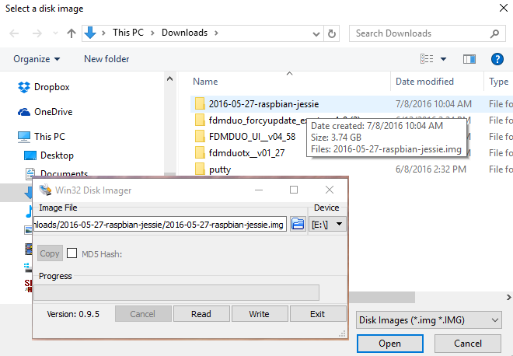

The following steps are related to programming/operating the pi from your laptop USB
Step 4 – Connect the Pi Zero to your laptop via the USB cable
Step 5 – In Windows Explorer, navigate to the SD card and edit the config.txt file with notepad or wordpad
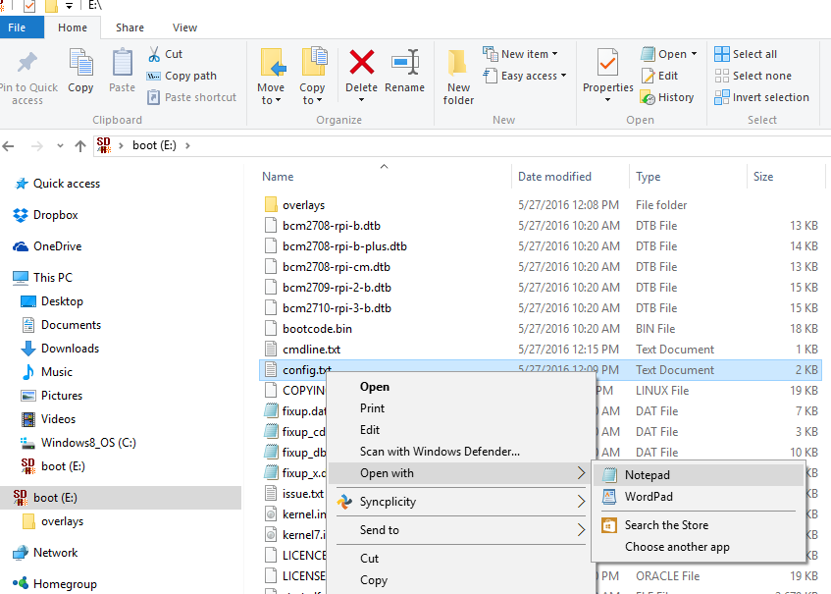
Step 6 – Scroll to bottom, add a line with this text: dtoverlay=dwc2

Step 7 – Edit cmdline.txt
Edit with Wordpad, and add these two lines at the very bottom:
# This is to enable putty sessions via usb on my laptop
dtoverlay=dwc2

In between the words “rootwait” and “quiet“ add in “modules-load=dwc2,g_ether” – be sure to notate a space before the phrase and after.
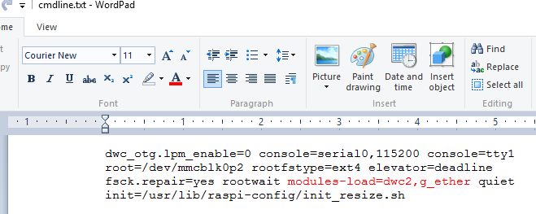

Step 8 – Open Putty
If you need putty, get it here: http://www.chiark.greenend.org.uk/~sgtatham/putty/download.html
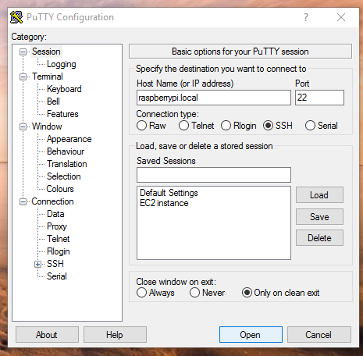
Type in “raspberrypi.local” in the Host name field, click open.
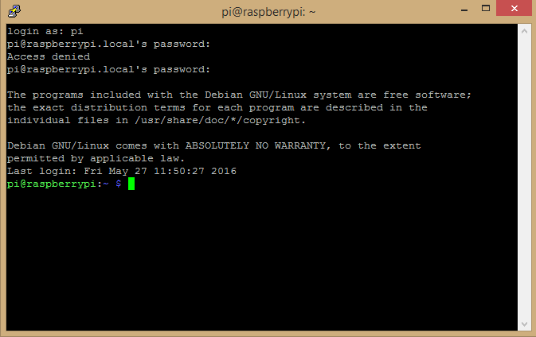

Step 9 – Install VNC for the laptop side of things
Choose the appropriate laptop OS.
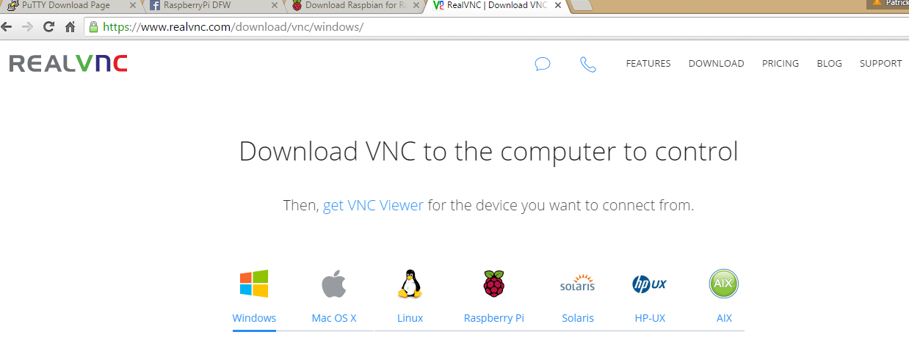

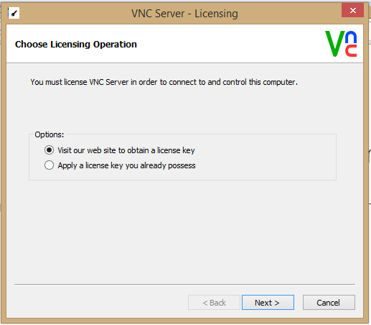

Need to get the free realvnc license key, go here: https://www.realvnc.com/purchase/activate/
Fill it out like this:
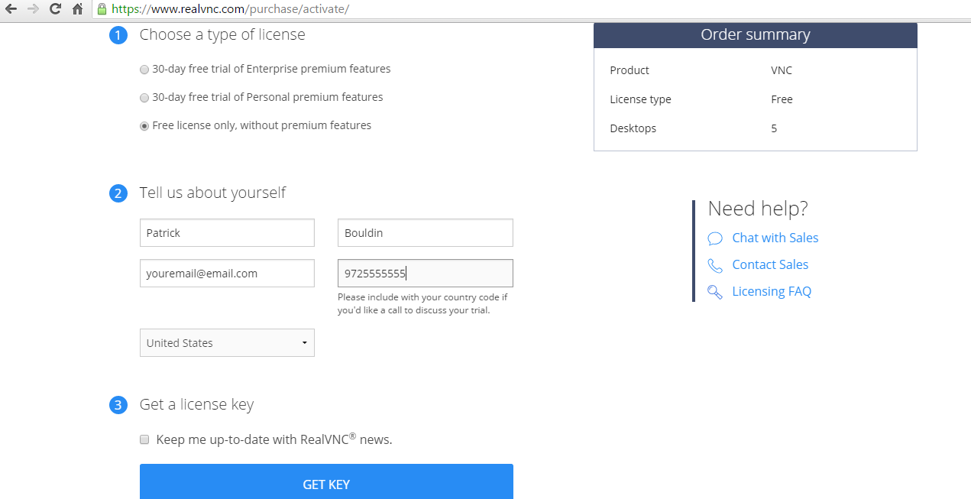

Of course with your info.
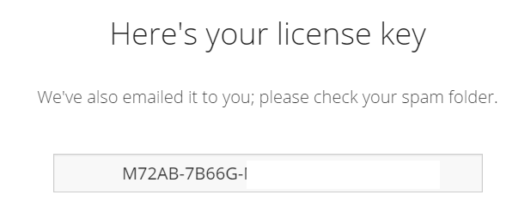
And you can use the issued key of course:
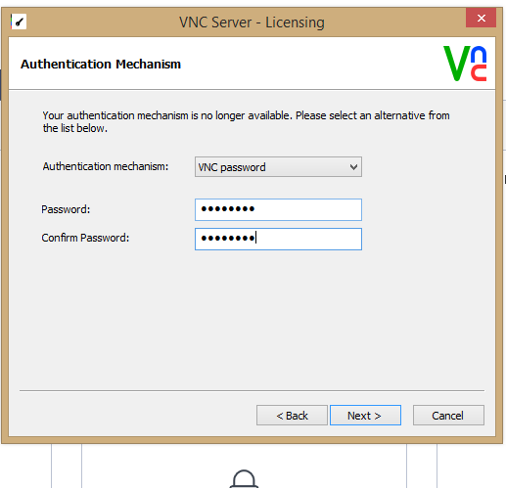

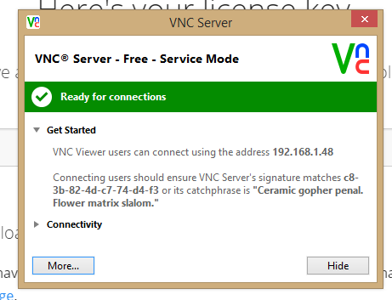

Now you need the software to run graphical on the pi side of this, so go to: https://github.com/realvnc/raspi-preview
Scroll down to installation and select “Download the VNC Server…” etc.
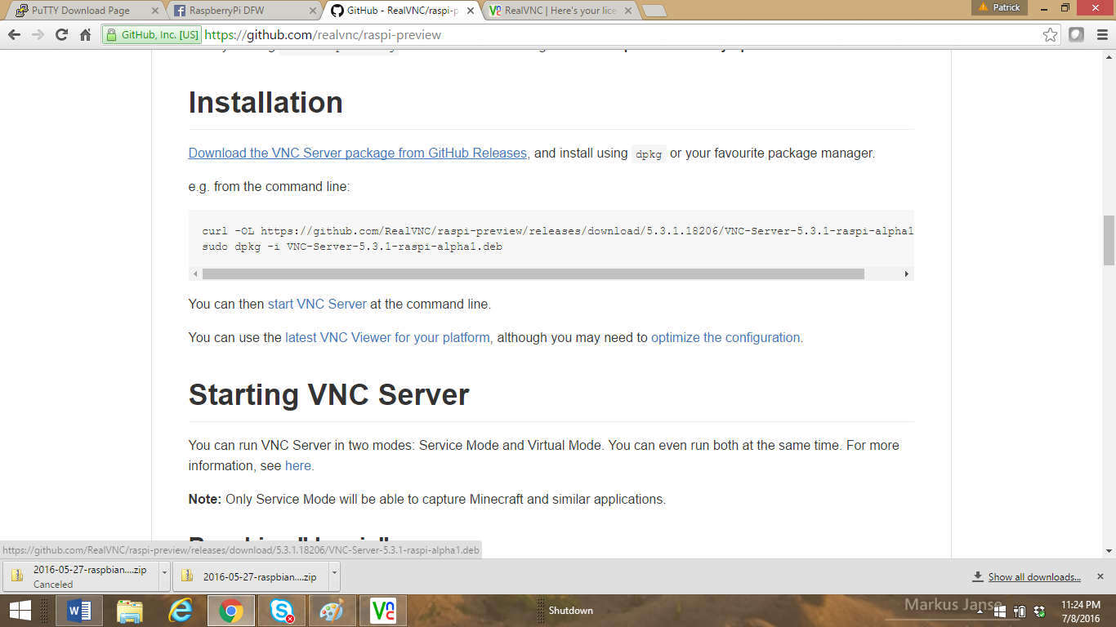
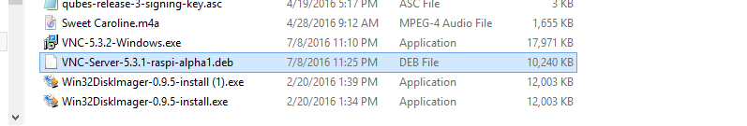
With a pi zero you don’t have a spare usb port, so they recommend to take out the SD card and put it in a pi 3 and then copy it over. Or, could use winscp file transfer which will
Get that here: https://winscp.net/eng/download.php
I know, groan, seems like a lot of work, keep in mind all this stuff is one-off, you can program any number of pi zeros without doing all this from now on!
Win installing WinSCP be sure to say YES when importing the Putty information. Notice my pi via usb info is there. However, you need to click “Edit” and put in the username and password that you use on the pi. If you haven’t changed it then of course the username is “pi” and the password is “raspberry”.
ou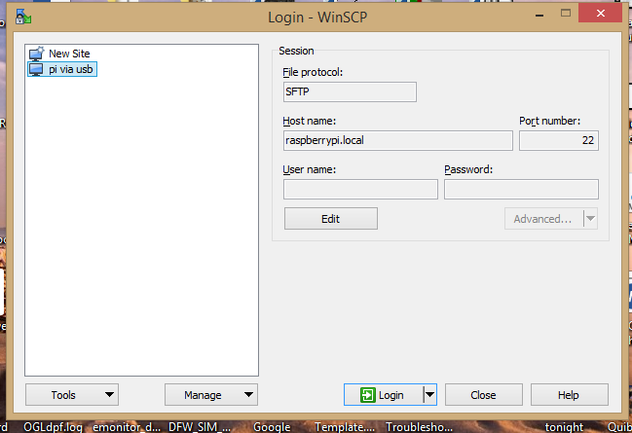

Once you connect you’ll see something like:
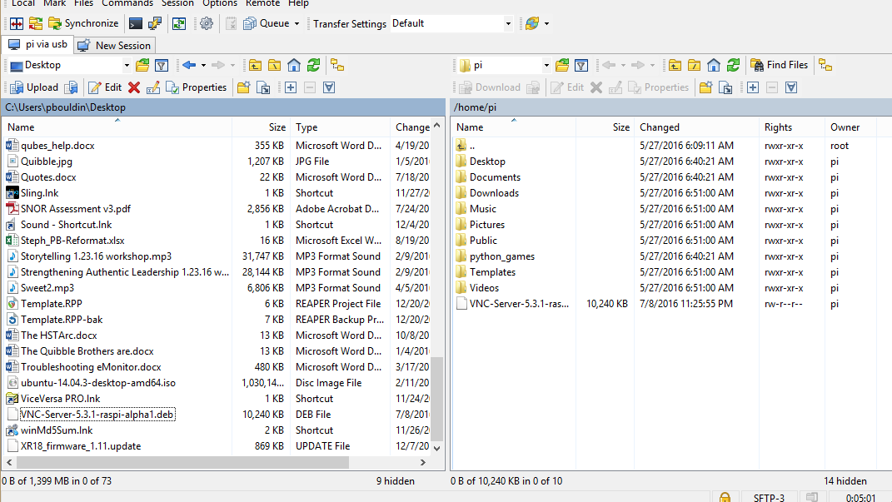
Just navigate on the left (PC side) and select the “VNC-Server…blah.deb” file and drag it over to the /home/pi directory on the pi (right hand side).
That’s it.
Now go back to putty, connect as before, and type this command:
“sudo dpkg –i VNC-Server-5.3.1-raspi-alpha1.deb”
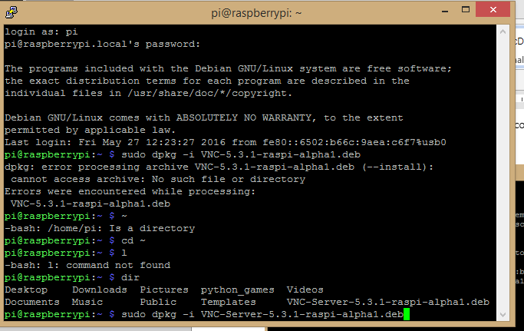
Note that as I was following instructions they were dated and you see a not found. So, best just to list the contents of the home directory first!
Now to change the pi to boot to the gui by default:
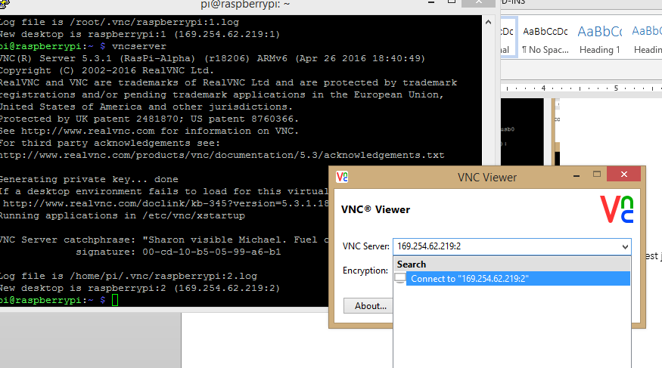
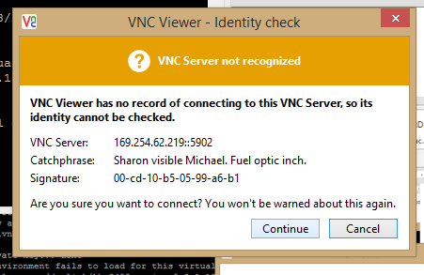

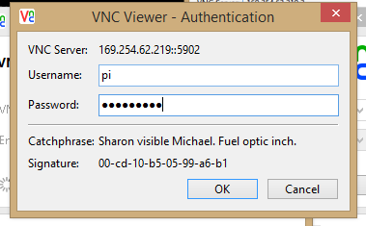
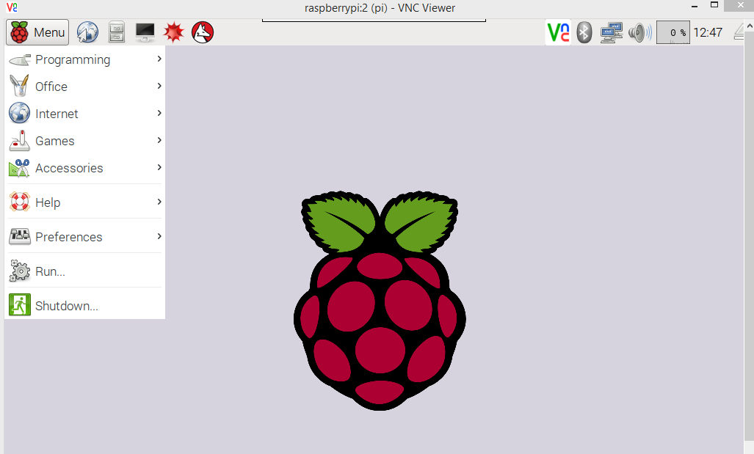
Yay! But why is my mouse an “X”?
Anyway, now we need to make the standard change where the pi boots to the graphical option. So, just open up a terminal (look at red circle at top). Type “sudo raspi-config”
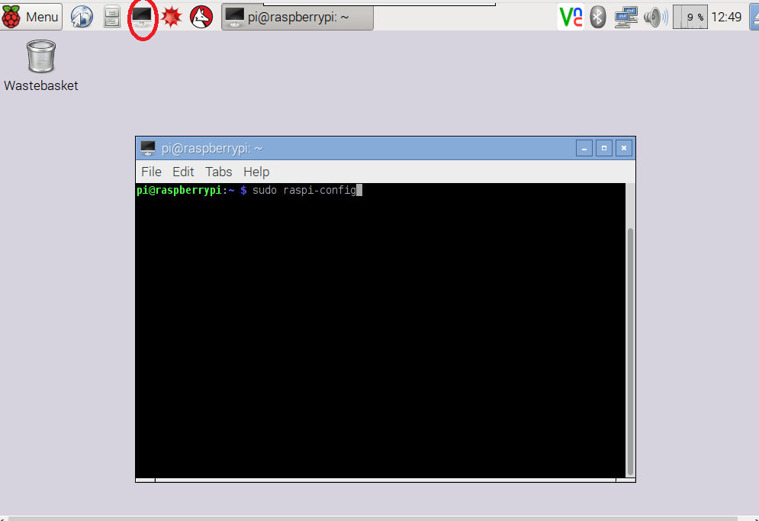
Scroll to boot options:
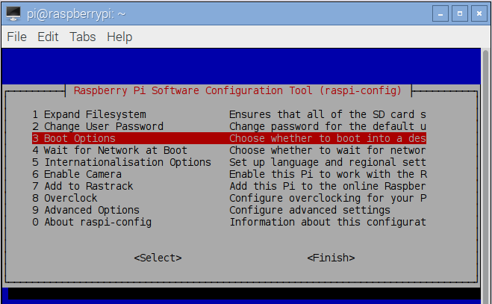
Select the B4 (Desktop Autologin..etc.)
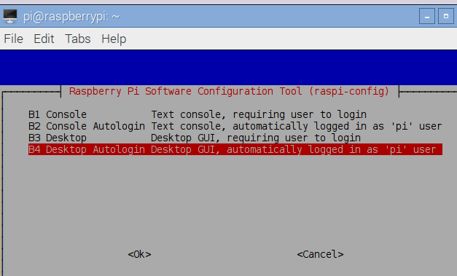
Click OK, then answer yes for reboot.
Now we need to set up the license key that we already signed up for. So in putty, log back in.
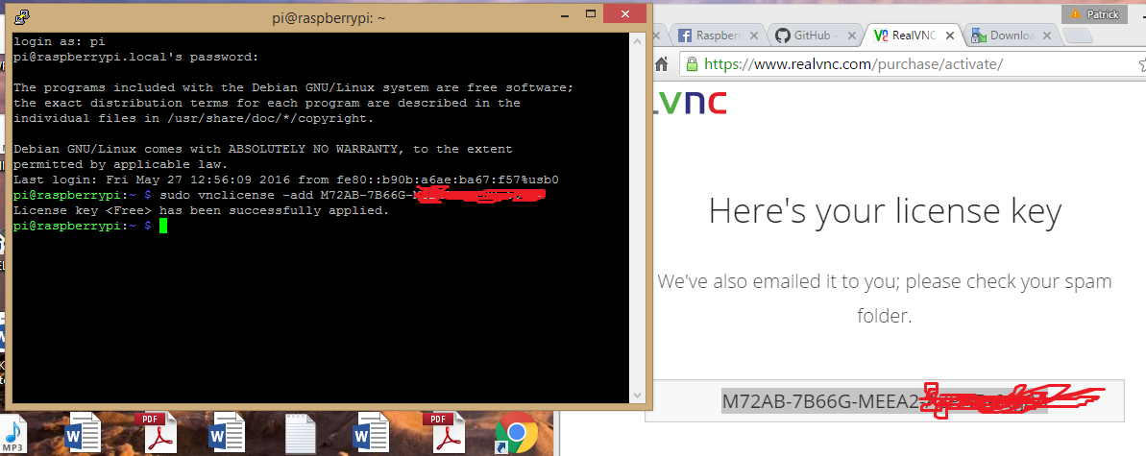
Now set up a password to access the role VNC, so…
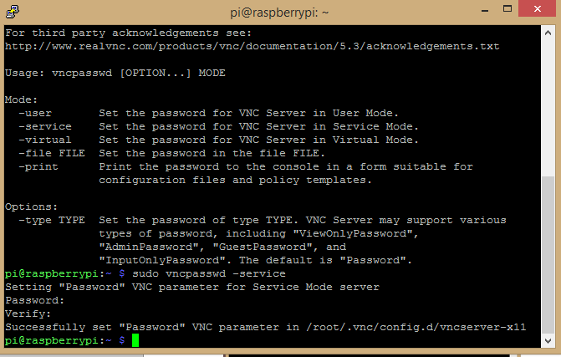
Now the last configuration to set up is to start the VNC whenever we start the pi. This will ensure everytime we plug in the pi in the USB port it will boot.
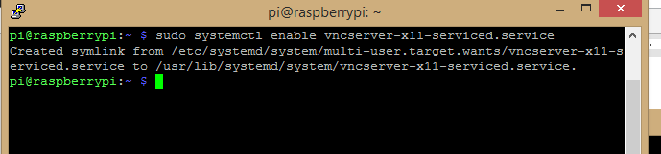
So the command is: sudo systemctl enable vncserver-x11-serviced.service
Note – the character on the right of “systemct” is a lower case L.
Close the session, go now into the VNC and make these changes:
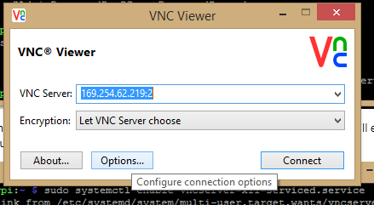
Click on Options.
Click on Advanced, then click on the Expert Tab.
In the Filter field type in “pre”
For the “PreferredEncoding” parameter choose “JPEG” as the value below it.
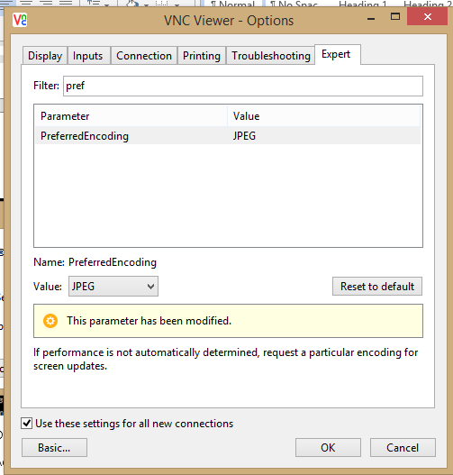
Now choose the AutoSelect and set to False…
Now choose the ColorLevel and set to Full…
Click ok, and then reboot.
When you reboot, then go back into VNC – it may show an IP address, I had trouble with that, just type in “raspberrypi.local” in the VNC server blank. Again, use the normal pi credentials.

All done!
Youtube of the end result:
https://www.youtube.com/watch?v=HCwsT9zK8uI

