Raspberry Asterisk Configuration
Part 1
DFW Raspberry Pi Meeting
The configuration of an Asterisk VoIP PBX server on the Raspberry Pi is taken in several
steps. These include:
- Initial Configuration
- Entering Extensions
– Local internal calls
- IP Phone Setup
3.1 Snom Phone
3.2
- Softphone Setup
4.1 Ekiga Configuration
4.2 Zoiper Configuration

Future Presentations
- Asterisk to Asterisk Configuration
5.1 Remote Extensions
5.2 General Remote Dialin
- SIP Carrier Options
6.1 ipcom.net
6.2 CallCentric.com
- Router Port Requirements
7.1 Basic Router Firewall Without NAT
7.2 Basic Router Firewall With NAT
- Asterisk to Carrier Configuration
- Asterisk Hardening
- Enhancements
10.1 Voicemail
10.2 Music On Hold
10.3 Announcements
10.4 Call Forwarding
10.5 MeetMe
10.6 Interactive Voice Recognition (IVR)
10.7 Conferencing
10.8 VoIP Phone Screen Display
10.9 GUI Front End

1. Initial Configuration
1. The Asterisk application must be installed on the Raspberry. This is a very simple process as it may be installed using the apt-get install process and is pre-configured for operation with sample files. It is also pre-configured as to the owner being “asterisk” which provides an initial security configuration. You can either use the sudo prefix or become the administrator (sudo su). It is easier to issue all of the commands as the administrator as you will be editing multiple files and using the Asterisk command line interface. It is also recommended that the files be opened in the background so that you may switch between them without having to close and open repeatedly.
- Issue the command apt-get update
- Issue the command apt-get upgrade
- Issue the command apt-get install asterisk
The installation includes the dahdi library. There is another library, LibPRI, which is available but is not installed.
Sit back and wait for the installation to complete, it takes a little while.
DAHDI is the Digium Asterisk Hardware Device Interface which is software to interface telephony interfaces. It should be installed even if no hardware is installed as it provides additional requirements such as MeetMe and is required for timing modules.
The LibPRI is not really necessary as it is required for a PRI interface which will not exist on the Raspberry Pi. It should be installed on a stand alone system that can have additional cards.
2. After the installation has been completed the server must be started.
- Issue the command asterisk service restart
Whenever a server needs to be restarted the above command is issued. If it has not yet started then the shutdown process will have no effect. Asterisk includes a utility to reread the configuration files while operating which precludes the requirement to restart.
3. Issue the command asterisk –r.
Remember that you must do this as the administrator, either using sudo or having become the root administrator
This will start the Asterisk CLI operation. It is required that the service has previously been started. When exiting, the service will remain operational. You will receive the prompt:
raspberrypi*CLI>
From now on only the CLI> will be shown.
4. For general purposes, display the initial dialplan by issuing the command:
show dialplan
The sample dialplan will be displayed. You will be making changes to this.
5. At any time the changes to any of the configuration files may be reloaded by issuing the command:
core reload
This is re-reads the /etc/asterisk configuration files.
6. To exit from the Asterisk CLI configuration issue the command:
CLI> exit
7. Obtain the IP address of your system by issuing the command:
sudo ifconfig
At this time only the IPv4 address will be used. Configuration for IPv6 is an advanced topic and will be covered. Record your address:
IPv4 Address:
Also log the Network address and the Broadcast address:
IPv4 Network Address:
IPv4 Subnet Address:
Next learn the router's address by issuing the following command:
# route
Under the Gateway heading you can fine the router's address. Log it:
Router IP Address:
You can also find the network address under Destination (ignore all 0.0.0.0 addresses:
IPv4 Network Address:
It may be better for the system to be set up with a static IP address. If a static address is required, the following procedure should be implemented:
# cd /etc/network
In this directory you will find the interfaces file. Use either leafpad or nano (or gedit the file).
# leafpad intserfacesl
You should find the following:
iface eth0 inet dhcp
Change this to: Example
iface eth0 inet static
address selected-IPv4-address 192.168.1.10
netmask above-subnet-mask 255.255.255.0
network above-network-address 192.168.1.0
broadcast above-broadcast-address 192.168.1.255
gateway above-gateway-address 192.168.1.1
Note that you might want to know the assigned address space of the DHCP server which is normally part of the Internet router. Assigning an address outside of that range will insure that no other system is also assigned the same address.
After the change is made you will be required to reboot or restart the service by issuing the following command:
# /etc/init.d/networking restart
8. Change to the /etc directory.
9. For protection purposes, make a backup copy of the Asterisk configuration files. It is a good point to have a backup since there is a lot of examples and documentation contained in them. Issue the commands from the /etc directory:
# mkdir asterisk.bk
# cp –r /etc/asterisk/* /etc/asterisk.bk/
10. If the service was not started the asterisk –c command may be issued to start Asterisk and bring up the console. The difference being that when one exits, Asterisk is shut down if the service has not been started.
11. During the installation Asterisk was set up as a startup service on booting. This can be validated by issuing the command:
# service – –status–all
This completes the basic setup.
Least it be said, there are many things going on in the background that provide many features. Except for a few configuration files they will be ignored for this basic setup.
The primary protocol for establishing a connection between two devices is SIP, Session Initiation Protocol. One's voice is actually carried by the RTP, Real Time Protocol. Digium also developed another protocol called IAX, Inter Asterisk Exchange, as an alternative to SIP. IAX has some advantages for inter Asterisk connection when there is a firewall and NAT involved. (IAX2 is the current version.)
In a normal PBX system one views phone extensions and trunks. Asterisk has a different perspective, namely a channel that can request a service and a set of instructions that deliver that service. The understanding of the coding is what provides how the service is delivered.
In Asterisk an Extension is the naming of a group of instructions that accomplish an action. The obvious action is to make a phone to ring but there are other options to enhance the total operation.
An Asterisk Extension is denoted as [extenName]. Virtually any unique name may be used but it is best practice to not use a user's name (that individual may leave the company). Setting the name to an extension is not encouraged because of security reasons but it is a simple way of doing things. One popular naming convention is to use the end device's MAC address, if you want to look it up and type in all those characters.

2. Entering Extensions
Once the basic setup has been completed, the initial dialplan needs to be developed.
Number of extension digits:
For this example 3 digits were selected.
First digit:
List the users and their extensions:
User's Name Extension
1.
2.
3.
4.
5.
A separate worksheet should be used to documenting what is to be done.
For initial setup you will require at least two extensions. Initially they will be configured for Snom phones but others will be similar.
For editing purposes the text editor leafpad is used. gedit is also an excellent text editor.
Two files will be modified at for the initial configuration. The files are quite long because of the extensive documentation / samples.
Where applicable the configuration for both System A and System B will be displayed along side of one another. If not, then both systems are the same.
Asterisk uses the concept of a channel which is defined by the sip.conf file. A channel specifies each end device that can originate a service request, note that a service includes a call but can have more options. The channel not only identifies the originating interface but also the destination. The dialplan, or connection is defined by the extensions.conf file. The dialplan specifies how the requested service is to be connected which would be the simple ringing of a phone but may include more enhanced features.
The following diagram provides a simple illustration of the connection of two telephones. Note that the telephone has been identified with a MAC number of the instrument but in this example we will be using extension numbers.
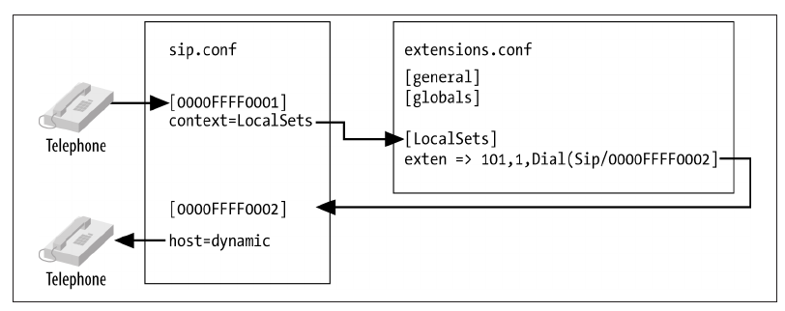
Realize that there actually two different connections being made in an Asterisk system. The first is from the first device to the Asterisk server, the second is from the Asterisk system to the second device. On the part of the first device, the connection has been completed when it connect to the server.

1. Edit the sip.conf file.
Search for [general].
The general section contains generic high level configuration that may be overwritten by other specific directions at a point.
2. Find the line context = public
This is a name that you select and is not critical as long as it is unique. It points to a section block of code in the extensions.conf file.
This can be changed but for now leave as it is.
3. Find the line udpbindaddr = 0.0.0.0
This specifies that UDP IPv4 connections are accepted. Leave it as is for now.
UDP specifies that the UDP protocol is used. This is the normal operation although some servers use TCP. The 0.0.0.0 says that it will accept any address. At this time the tcpenable = no remains as a TCP connection is not used.
4. Find the line transport = udp
This specifies that the default protocol for outgoing calls is UDP.
5. Find the line allowguest
For now comment this out because unauthenticated calls will not be allowed. At a later time one might wish to allow an unauthorized guest.
6. Find the section for the [snom] phone. We are using this section because that is the type of phone that was available for the test.
7. Copy the [snom] section and paste it at least twice to the bottom of the file (once for each phone that is being set up). There is a lot of extra information and much will be deleted as it is either unnecessary or example. The file contains many examples so you might want to look through the code to find an example for the phone that you are using.
If you look at several of the other phone entries you will see that they all look fairly similar with some minor variations.
If you have a different vendor phone find that section and copy it down to the end of the file.
8. Go to the first section. Make the following change:
[snom] → [extension]
For this example the extension was set to 314 on Station A and 414 on Station B.
9. Go to the second section. Change the extension to another number.
For this example the extension was set to 315 on Station A and 415 on Station B.
10. Uncomment the following (remove the semicolon).
[snom] change to [314]
type = friend leave as friend
context = from-sip change to context = internal
secret = blah change to secret = 314
host = dynamic leave as host = dynamic
dtmfmode = inband change to dtmfmode = auto
It is important to note that the context name can contain no spaces. Things don't work right if there are.
Type specifies the type of connection. Options are:
peer Match request to IP address and port
user Match request to configuration username in the From
header
friend Matches for both peer and user
Context specifies the code section in the extensions.conf file.
Secret specifies a password. For simplicity it is set to the extension number but this is a poor process.
Host specifies the type of connection. It is set to determine what needs to be done rather than a specific location. If a phone is to exclusively ring a specific location then a pointer can be specified, such as an IP address.
11. Delete all other lines that are commented out. At this time they are not needed.
12. Do the same to the second copy of the [snom]. The only difference will be to change to a different extension number. For this example it will be 315.
The commented lines are not needed so there is no problem deleting them.

In Review
Setting Station A Station B
[ChannelName] [314] [414]
type= friend friend
context= internal internal
host= dynamic dynamic
dtmfmode= auto auto
[ChannelName] [315] [415]
type= friend friend
context= internal internal
host= dynamic dynamic
dtmfmode= auto auto

An alternative to SIP is IAX (version 2). The benefit of using IAX is simpler configuration when using a firewall and NAT. For those connections requiring IAX, the iax.conf file is used. IAX uses a single port (4569) whereas SIP uses ports 5059 ~ 5061, 5060 is the most commonly used.
13. Save and close the file.
14. From the asterisk CLI issue the commands:
CLI> core reload
CLI> sip show peers
CLI> sip show users
This will display the configurations that were just completed to the sip.conf file.
15. Edit the extensions.conf file.
16. Go to the end of the file.
17. Create a new section with the following format:
[internal] This is required because you specified it internal in the sip.conf file.
18. Add the following line:
include => demo
This specifies to use the demo section of the file in the local internal section. This is section already exists and no further action is required. At a future date one might wish to comment it out.

19. Set up two extensions (314 and 315 for this example).
Station A Station B
exten => 314,1,Dial(SIP/314) exten => 414,1,Dial(SIP/414)
exten => 315,1,Dial(SIP/315) exten => 415,1,Dial(SIP/415)
As a generic form, look at the entry as:
exten => Name,Step,Application(Protocol,Destination)
Where:
Name specifies the identifier for termination, the number dialed.
Step specifies the order in which actions are to be taken. It is also known as
the priority. Multiple steps may be set up for call routing.
Application specifies what action is to be performed. Many more
applications exist besides Dial.
Protocol specifies the protocol that is to be used.
Destination specifies where the connection is to be completed to.
exten specifies that a channel is being set up.
314 specifies that the number 314, 315, 414, or 415 was dialed by a user.
1 specifies that this is the first of multiple (optional) steps is so configured.
Dial specifies that the following connection to to be established.
SIP specifies that the SIP protocol is to be used to establish the connection.
314 specifies that a connection to the 314 extension is to be established.
The second 314 specifies the device name to connect to. Although not optimum for security purposes, the extension number has been specified. The MAC number of the terminating station could be used if you want to type that much without making a mistake.
For this simple installation there should only be a single entry for each extension. Asterisk is capable of supporting multiple commands for a specified extension but that is not reviewed at this time.
20. Save and close the file.
21. Open an asterisk console:
# asterisk –r
22. Issue the command:
CLI> core reload
This reloads the configuration files.
23. Issue the command to display the dialplan:
dialplan show internal
Note that then name “internal” is the name that was assigned inside the extenions.conf file. If a different name is used, then use that designation in the command.
This completes the basic configuration for internal telephone connection.
In our example we have assigned the station number to the Channel Name. It does not have to be the dialed number but instead could be a name (or MAC address). It could also point to a group of phones in a more advanced configuration. The Channel Name could also be user's name (discouraged) or an email address.

3. IP Phone Configuration

3.1 snom Phone Configuration
The following configures the snom phone.
The information that must be recorded is displayed only for a short period of time so be ready to copy the information down.
1. The IPv4 address of the phone must be logged down as it will be used in the configuration of the phone via a web browser. At this time many phones may not be able to support IPv6.
2. Unplug the power for the phone and plug it back in. The screen on the phone will display IP address at some point, but it is only displayed for a few seconds. Record the IP address.
Phone IP Address:
The IP address is required to complete the phone configuration.
3. Open a web browser and enter the IP address into the URL.
4. A list of options is displayed on the left side of the browser. Click on identity 1.
5. Under the Login Tab enter the following information:
Display name: Enter User's Name
Account: Enter User's Extension
Password: Enter User's Extension
Registrar: Enter Asterisk IPv4 Address
Outbound Proxy: Enter Asterisk IPv4 Address
Authentication Username: Enter User's Extension
Mailbox: n/a at this time
6. Under the RTP Tab validate that the RTP Encryption option is OFF.
7. The phone may be able to attach to multiple PBX servers, which is the reason for having multiple identity options. That is an advanced configuration.
8. Go back to the Login Tab.
Click on the Save button.
Click on the Reregister button.
Note that the two buttons appear to be grayed out but they still work.
Watch the lower left corner of your browser and you will see it blink the
IP address.
9. The phone should now be registered with the Asterisk server. From the CLI issue the command:
CLI>sip show peers
You should now observe:
raspberrypi*CLI> sip show peers
Name/username Host Dyn Forcerport Comedia ACL Port Status Description
314/314 192.168.0.74 D Auto (No) No 2051 Unmonitored

This completes the setup of the phone.
You should now be able to dial between the phones by dialing the designated extension.
Dialing the number 500 should dial Digium as test connection for a connection through one's Internet connection.
Dialing the number 600 should provide a loopback connection to listen to the echo created by the system.

4. Softphone Configuration

4.1 Ekiga Configuration
Ekiga, formally known a GnomeMeeting, is a free softphone application. It is typically installable as a download for Linux (apt-get / yum / yast) and as a download for MS Windows from http://www.ekiga.org/download-ekiga-binaries-or-source-code .
After configuration you will require a headset / microphone to make a call.
The first time Ekiga is opened the Configuration Assistant will open, but if it does not one can open it from the Edit Menu in the Task Bar from the window that does open.
1. In the Personal Information window, enter your name. In versions from 4.2.0 and on this screen may not appear as it is not needed.
2. The next window is the Introduction to Account. It is information only saying that you can obtain an account from Ekiga.net.
3. In the Ekiga.net Account window they ask for one's Ekiga.net account and password. Do not enter anything into this screen. At the bottom of the screen check off the box for I do not want to sign up for the ekiga.net free service.
4. The Ekiga Call Out Account window opens. Since an Ekiga.net account has not been obtained this window can be ignored. At the bottom check off the box for I do not want to sign up for the Ekiga Call Out service.
5. The Connection Type window opens. Starting with version 4.2.0 this screen no longer appears. If this window appears, select LAN.
6. The Audio Devices window opens. Unless there is a reason to do otherwise, leave the default settings. Because of the design of the Raspberry Pi, it is recommended to not set up Ekiga on it due to the audio jack issues. (It can be done but not not detailed here.) Since Ekiga automatically detects the the various interfaces that are available, this option no longer appears as of version 4.2.0.
7. The Video Input Device window opens. The video input is automatically detected so as of version 4.2.0 this screen may not appear. The important issue is to have a webcam plugged into one's computer prior to starting Ekiga, which allows the system to auto detect it. This is necessary only for those wishing to utilize video.
8. The Configuration Complete window opens. This summarizes the settings just set. Click the apply button, assuming all is correct.
9. An account must now be established to the Asterisk system. From the main Ekiga window select Accounts from the Edit menu in the Task Bar.
10. From the Accounts window, select Add a SIP Account.
11. Enter the following:
Name: Enter the name of the user if desired, one's extension, other information, or leave it blank. Your choice.
Registrar: Enter the IP address of the Asterisk server.
User: Enter the extension for this phone (315).
Password: Enter the password for the extension, which in our case is the extension number (315).
Timeout: Leave it at the default of 3600.
12. At the bottom of the window check the Enable Account box.
13. The Accounts window again opens with the entry that you just made. You should see the Account Name and the Status of Registered.
14. If an H.323 connection is to be used, click the Add H.323 Account from the Accounts drop down menu.
15. If being set up, enter the following:
Name: The name of the user if desired.
Registrar: Enter the IP address of the Asterisk server.
User: Enter the extension for this video phone (315).
Authentication: Enter the extension for this phone
Password: Enter the password for the extension (315).
Timeout: Leave it at the default of 3600.
16. Back at the asterisk –r CLI> prompt, issue the command:
sip show peers
You should now see the extension for your Ekiga phone as being registered with the IP Address that it exists on and the port that it is using for SIP (5060).
17. The Preferences needs to be configured. From the Edit drop down menu select Preferences. The Ekiga Preferences window opens with a long list of configuration options.
18. This section should be reviewed to validate. Change only if necessary.
General – Personal Data. Should show your user name that was previously entered.
General – General Settings. Accept defaults.
General – Call Options. Accept defaults.
General – Sound Events. Accept defaults.
Protocols – SIP Settings. Accept defaults.
Protocols – H.323 Settings. Accept defaults.
Audio – Devices. Accept defaults.
Audio – Codecs. Accept defaults.
Video – Devices. Accept defaults.
Video – Codecs. Accept defaults.
19. For Linux, the firewall may require modification in order to allow traffic to flow. The ports 5060 for SIP and 10000~20000 for RTP may be required to be open.
Note that a basic configuration for assigning an extension can be very simple. It really doesn't get too much more complicated when additional features are added.

4.2 Zoiper Configuration
Zoiper makes a free distribution of a softphone for personal use and a commercial version for business. This has been installed and tested. It works great and configuration is straight forward. It supports both MS Windows and Linux.
1. After unzipping / untarring the file two installation files will be available, 32 bit and 64 bit. Select the appropriate installation.
As the administrator issue the command to install:
# cd location-of-Zoiper-installation-file
# ./Zoiper-3.2_Linux_Free_32Bit.run
2. The Zoiper Setup screen appears, click Forward.
3. You have to accept the licencing agreement otherwise you are wasting your time.
4. Select components – accept the defaults.
5. Select the default installation directory.
6. Continue with the installation.
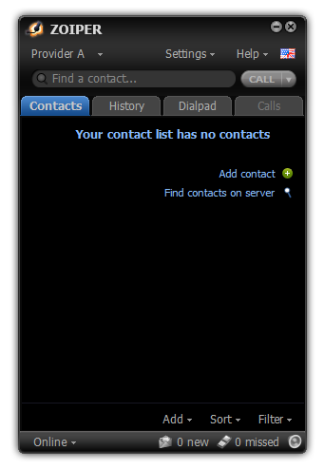
7. You may be given the option to immediately launch Zoiper, take it so that you can continue with the configuration. It is assumed at this point that the free version has been installed and therefore Business edition does not require authentication.
8. The Zoiper phone screen opens.

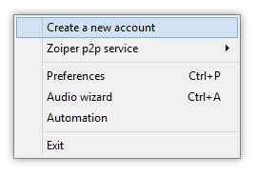
9. Click on the Settings area at the top to select various configurations. This will open a drop down menu.

10. Select Create a new account.

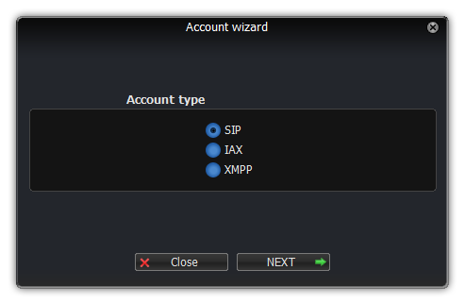
11. From the Account Wizard select an Account type of SIP.

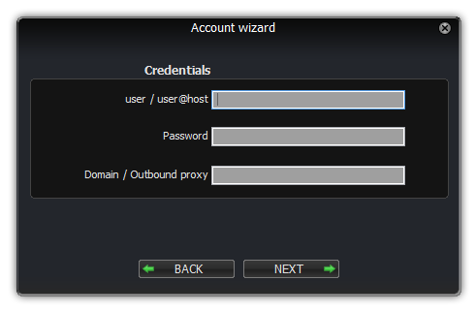
12. Add the appropriate credentials
For the user account account number (extension number) or your name. If your name enter as John.Doe with no spaces.
For the Password enter the secret value (extension number).
For the Domain enter the IP address of the Asterisk server.

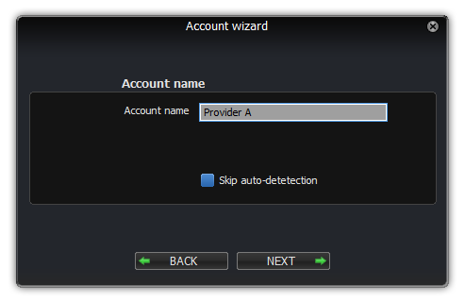
13. Finally enter an Account Name, such as Raspberry Asterisk. You can leave it as the default entry, which is typically extension@domain (i.e. 111@192.168.1.10). This can be changed later if you want.

14. At this point the system will attempt to authenticate with the Asterisk server. It should be successful.
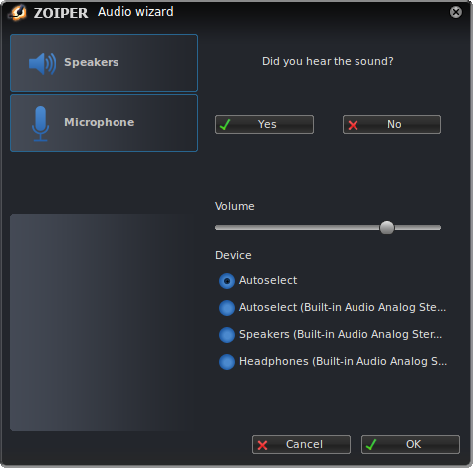
15. From the Settings drop down menu select Audio Wizard. You can test both the speakers and microphone.
16. Zoiper auto detects the settings of one's operating system so generally nothing has to be done.
17. Validate that the speakers operate correctly and adjust the volume.
18. Validate that the microphone operates correctly and adjust the volume. You may notice that the meter displays your voice but you do not hear any sound, this issue will be addressed in the ADVANCED tab.
19. Although not shown in these screen shots Zoiper now supports video. This has yet to be configured and tested.
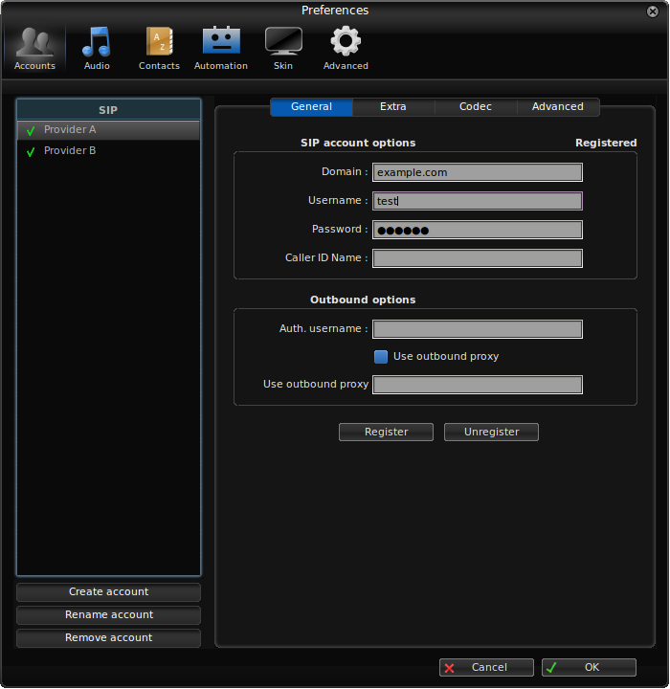
20. From the Settings Menu drop down select Preferences
21. Under the GENERAL tab it displays the entries that were made when the account was set up. If changes are necessary they can be made from this screen. Multiple accounts will be displayed in the left hand column.
22. As an option your name can be filled into the Caller ID Name, thus allowing one's name to be displayed in a caller ID to another phone. Note that it should be limited to 16 characters.
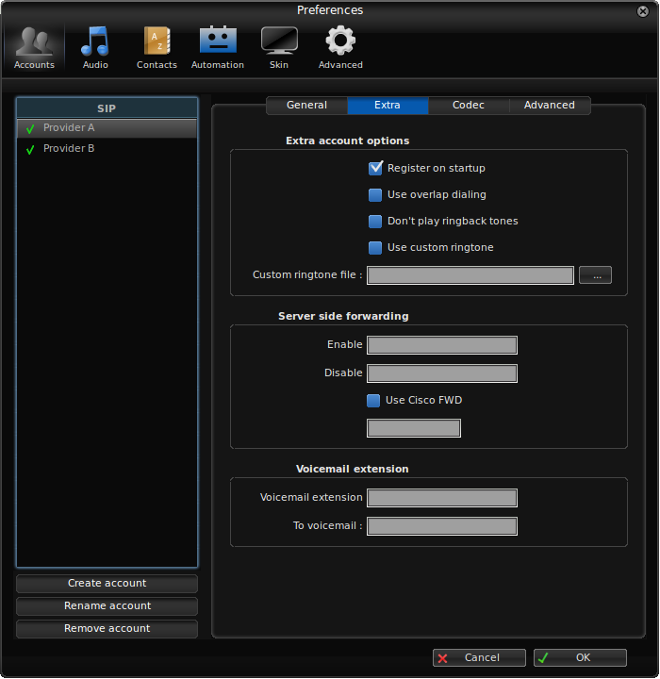
23. Under the EXTRA tab is displayed various options. By default the only option that is checked off is for the phone to register when the application starts. No other options are necessary.

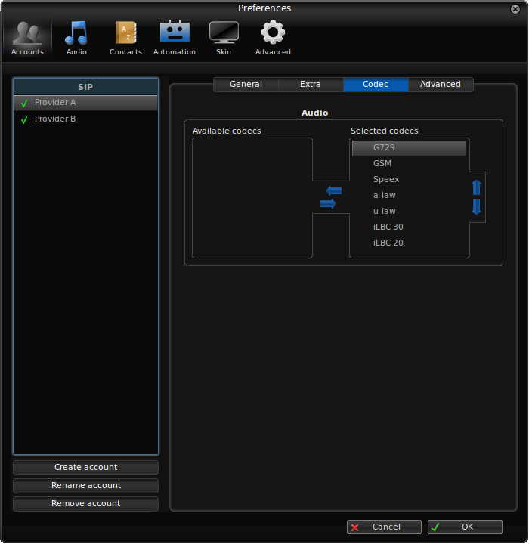
24. Under the CODEC tab is displayed the various encoding algorithms supported by Zoiper. No changes should be necessary unless specifically required.

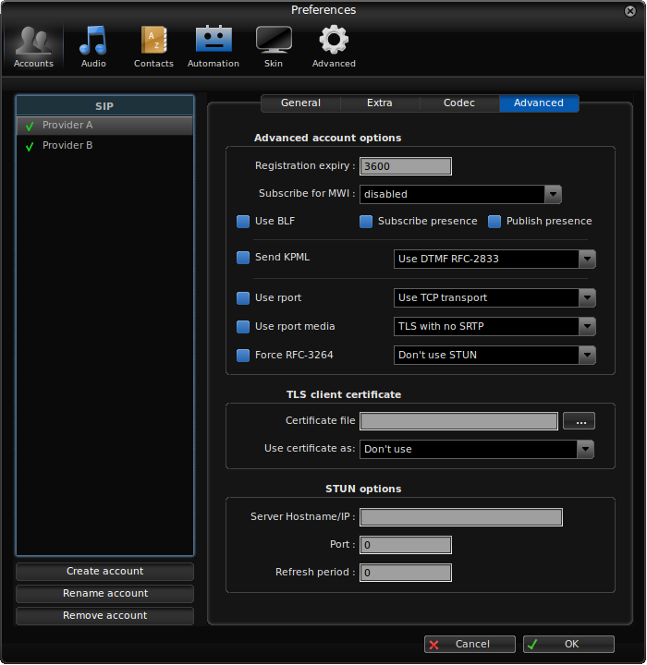
25. Under the ADVANCED tab several options exist that may require change.
26. There may be audio problems when placing a call to another use in that the audio may not be heard. To test this out place a call to extension 600, the latency echo response line. When speaking into the microphone one should normally hear oneself in the speakers (with a very slight delay).
27. If you do not hear yourself then make sure that the option for
A. UDP/TCP/TLS specifies
USE UDP Transport
B. For the STUN option specifies Don't use STUN.
28. If you didn't have audio before you should now have it. You may need to go back to the Audio Wizard to adjust the volumes.
The configuration of the Zoiper is now complete and you should be able to make calls to other extensions.

Asterisk The Definitive Guide, 4th Ed., Russel Bryant, 2013

